PROGRAM – 32, 33, 34

HARINI. R

192324108

32. Write a LEX Program to convert the substring abc to ABC from the given input string

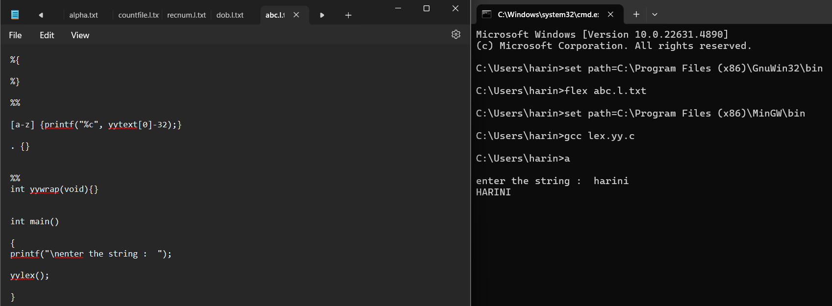

33. Implement Lexical Analyzer using FLEX (Fast Lexical Analyzer). The program should separate the tokens in the given C program and display with appropriate caption.

34. Write a LEX program to separate the keywords and identifiers.

